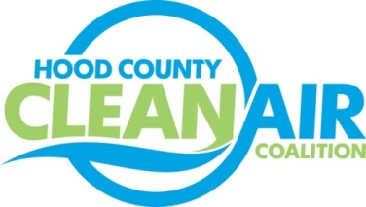
Meeting: Thursday, May 3, 2018
Neely House
304 East Rucker Street, Granbury, Texas 76048
8:30-10:00 a.m.

Agenda

- Call Meeting to Order
- EPA Updates – Randy Pitre, EPA
- Local Updates – Michelle McKenzie
  - Review of April Meeting Summary
  - Annual Minutes
  - Review of Projects
    - Monthly Budget Review for March
    - Status of Projects FY 16/17/18
    - Office Status
  - Alternative Funding Status
  - April Ozone Update
4.) Regional Updates – Michelle McKenzie
  - Clean Air Action Day on June 22: www.airnorthtexas.org/cleanairactionday
  - Energy Efficiency Workshop May 8, Register at http://www.nctcog.org/envir/events.asp
  - Upcoming DFW Clean Cities Events
    - May 15: Workshop about grant funding and financial assistance available to transition to ethanol fuels
    - May 23: Alternative fuel vehicle displays in conjunction with the NCTCOG Public Works Round-Up
  - Funding Opportunities, www.nctcog.org/aqfunding
  - EPA National Clean Diesel Funding Assistance Program
  - Volkswagen Settlement Update
5.) Other Discussion
6.) Adjourn

